Anti-bullying at North Ridge High School

What is bullying?

A bully is someone who hurts someone more than once, by using words or behaviour which is meant to make them upset or frightened.

Bullying can take different forms:
- Emotional: Hurting people’s feelings, leaving people out
- Physical: Punching, kicking, spitting, hitting, pushing.
- Verbal: Being teased, name calling, rude comments.
- Cyber: Saying unkind things by texts, e -mail or online.

How will we try to protect you?

- We will provide a safe environment.
- We will listen to your feelings.
- We will support you and help to make things better.
- We will talk to the bully about how they have made you feel.

If you or your friend are being bullied:

- Ignore: don’t try and get your own back
- Talk firmly: tell the bully to stop
- Walk away: find somewhere you feel safe
- Report: tell a safe adult

If you need to talk – we will listen!

Anti-bullying at North Ridge High School

What is bullying?
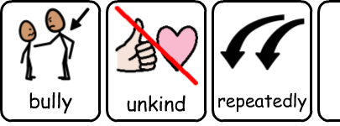
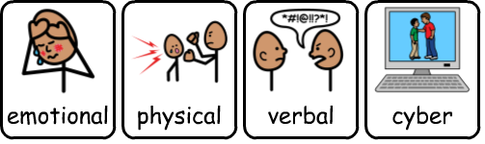
How will we try to protect you?
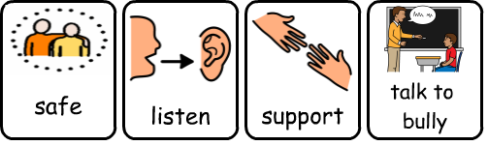
If you or your friend are being bullied:
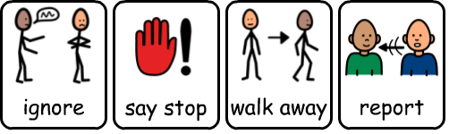

If you need to talk – we will listen!
