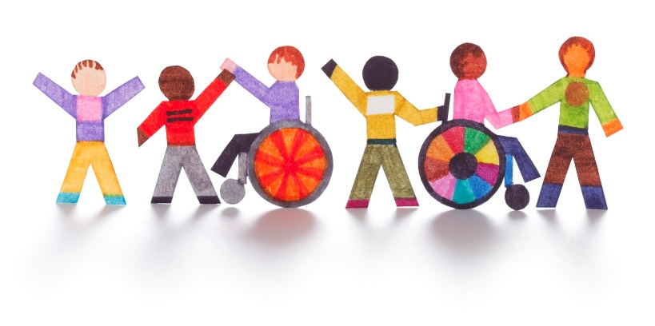
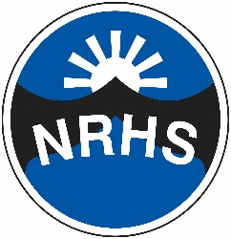
Child Protection at North Ridge High School

What is child protection about?
It is your right to be safe.
At North Ridge High school we want you to feel safe.
How will we try to protect you?
- We will provide a safe environment for you to learn in.
- We want to ensure that you remain safe, at home as well as at school.
- We think it is important for you to know where to get help if you are worried or unhappy about something.
If you need to talk – we will listen!
- You can talk to any adult in school.
Don’t keep it a secret if someone is:
- Bullying you;
- Saying funny things to you that you do not like or which upsets you;
- Touching you;
- Hitting you or hurting you;
- Taking your things;
- Sending unkind messages on the internet or to your phone.
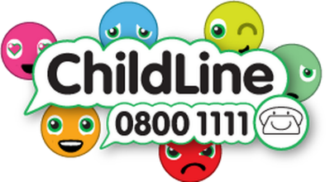
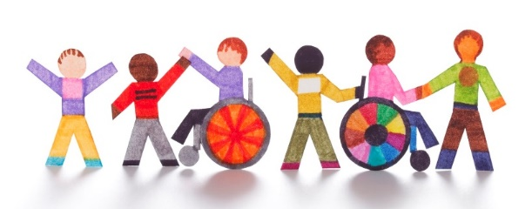
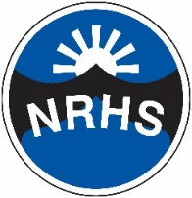
Child Protection at North Ridge High School

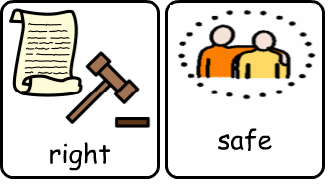
What is child protection about?

How will we try to protect you?
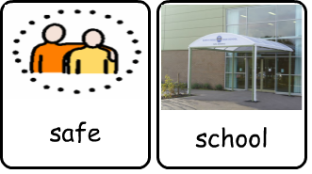
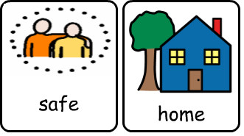

If you need to talk – we will listen!
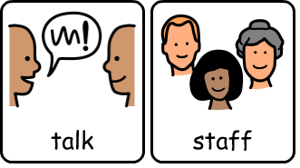

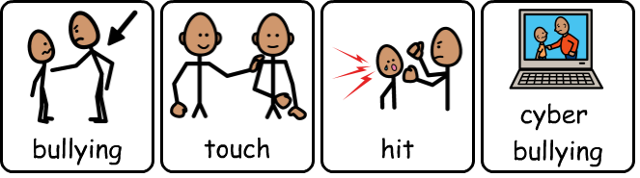
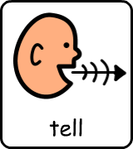
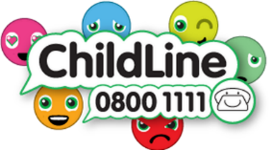
Tell someone if:

