

**Behaviour Tool Kit**

This tool kit has been designed to give you some key resources when managing behaviour of supported learners. Inside this tool kit you will find:

• An Emotions board

• A Reward chart

• A Now and Next board

• A Social Story

• And Traffic lights

All resources have been designed so that you are able to adapt them and personalise them to the needs of your student. All information on how to use these resources including video tutorials and guidance sheets can be found on our website at

https://northridge.manchester.sch.uk/nrhs/resources-and-support/

For any queries please contact:

Email: W.Errock@northridge.manchester.sch.uk

C.Graham@northridge.manchester.sch.uk

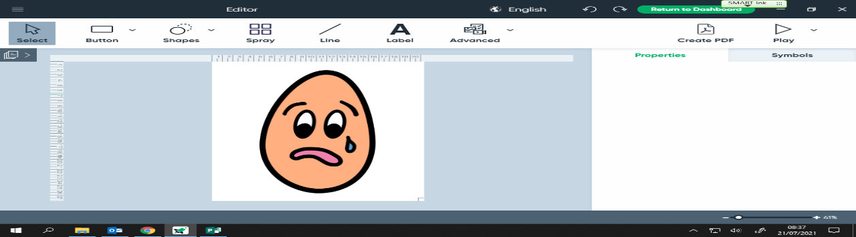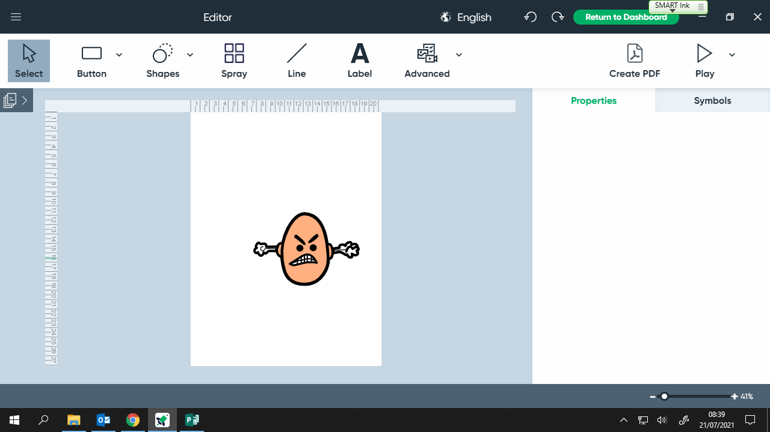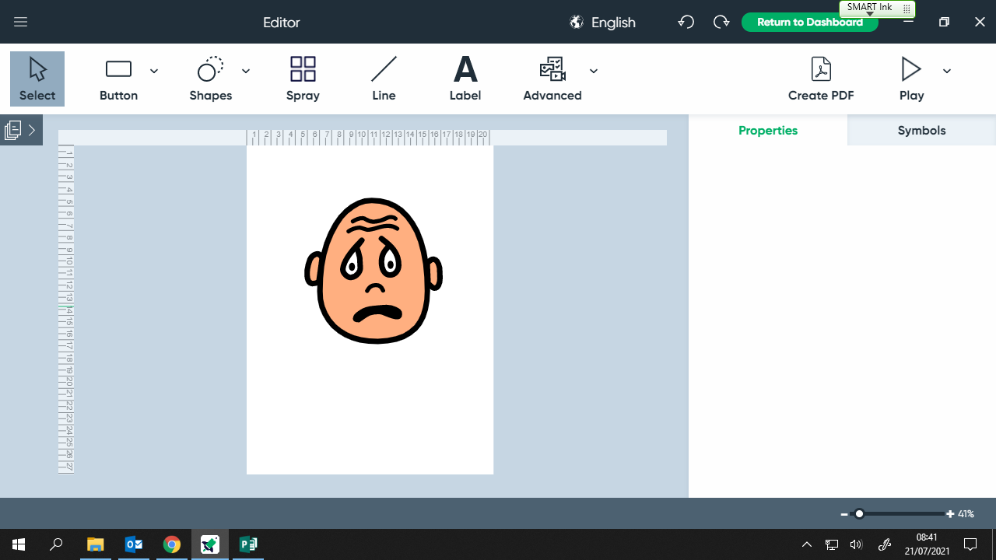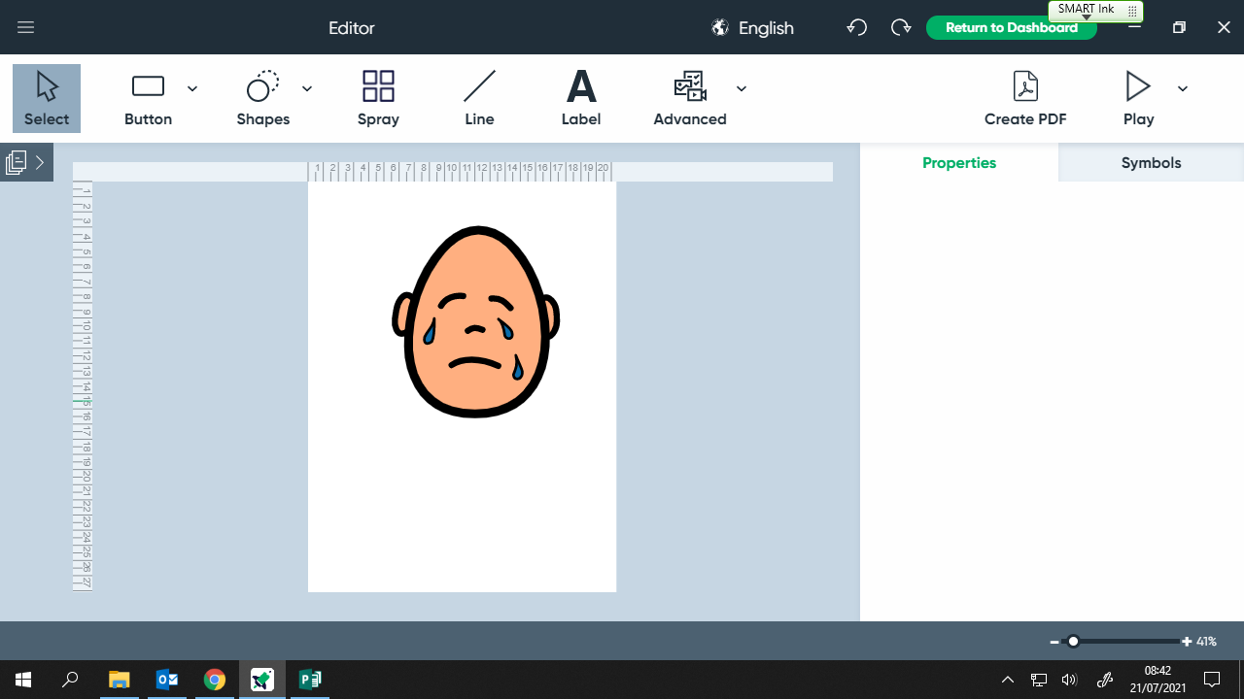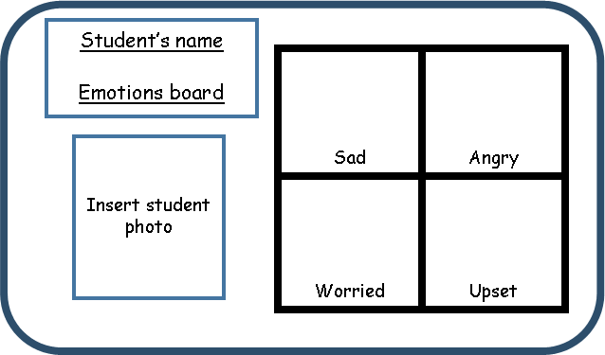

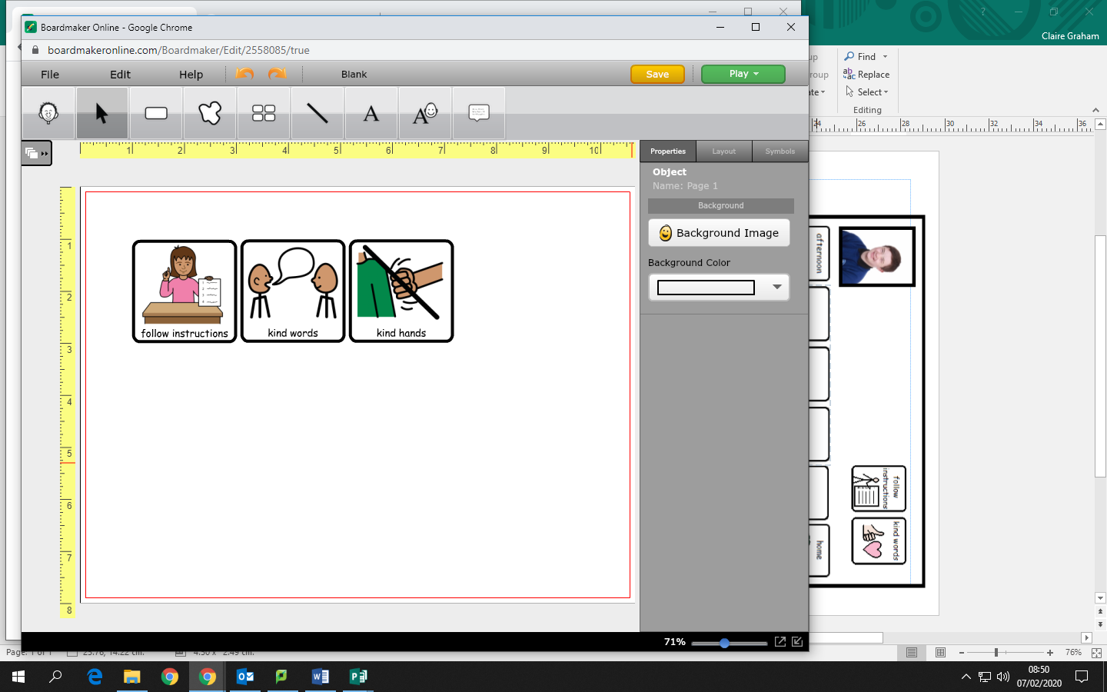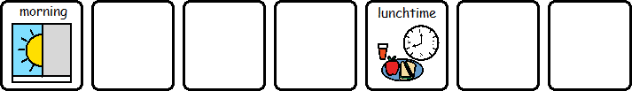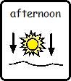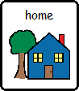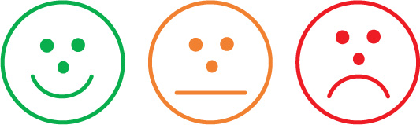

**INSERT**

**STUDENT**

**PHOTO**

**INSERT WHAT REWARDS THEY ARE WORKING TOWARDS HERE**

**INSERT**

**STUDENT**

**PHOTO**

**INSERT WHAT REWARDS THEY ARE WORKING TOWARDS HERE**

You can add and delete the boxes based on the number of lessons you have in the morning and afternoon.

If you need another symbol for their target other than follow instructions please get in touch or type a different target at the top if this would be better suited to your student.

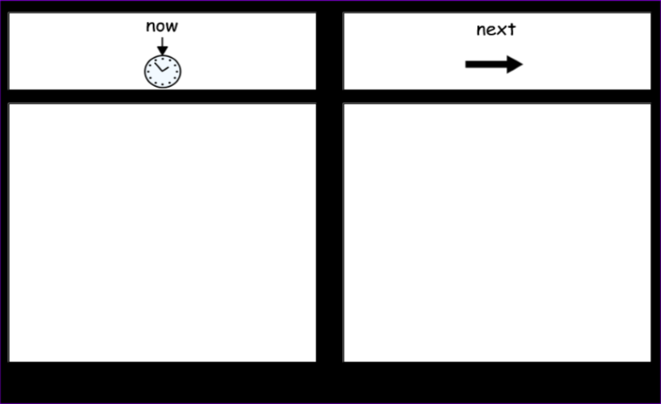

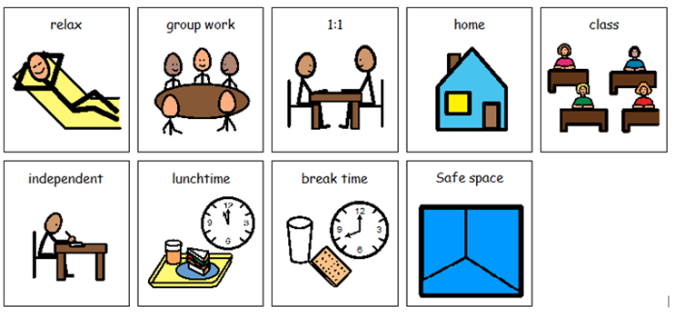

These are some of the basic symbols we use. Please get in contact if you need further assistance with symbols

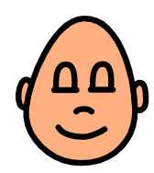

**Student Name**

**Social Story**

**When I feel angry.**

Insert student phot

In school I am safe.

 My staff are here to keep me safe.

I can talk to my staff about anything and they will listen.

 Sometimes I might not like something that someone has done or said and that is ok.

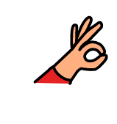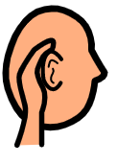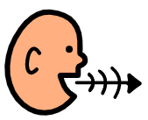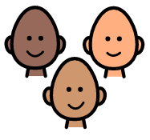

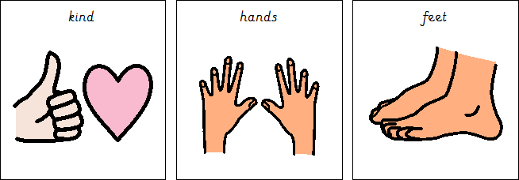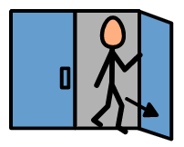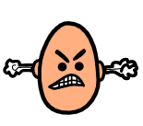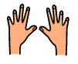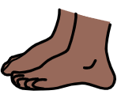

If I don’t like something someone has done or said I can talk to staff about

it.

 If I feel like I might be getting angry I can use my time out cards to leave the class room and calm outside the classroom.

 I know when I am getting angry and can identify when I need to leave the room.

If I am angry I will use kind hands and feet to keep myself and others safe.

When I am angry my staff will do what they can to keep me and others safe. I can talk and they will listen.

 If I am using kind hands and feet my staff will be able to listen to why I am upset.

 When I make the choice to leave the room and use kind hands and feet I am keeping myself, students and staff safe





When I am making good choices I am making my friends, family and staff happy.

