

This tool kit has been designed to give you some key resources when supporting independent learners with making friends around school. Inside this tool kit you will find:

• Social story

• Worksheet about friends

• Scenario cards

All resources have been designed so that you are able to adapt them and personalise them to the needs of your student. All information on how to use these resources including video tutorials and guidance sheets can be found on our website at

https://northridge.manchester.sch.uk/nrhs/resources-and-support/

For any queries please contact:

Email: W.Errock@northridge.manchester.sch.uk

C.Graham@northridge.manchester.sch.uk

**Being a good friend**

It can be easy to be a good friend.

Lots of people want to be my friend in school.

To be a good friend I need to use a calm voice and kind words.

Swearing and name calling is inappropriate.

When I use inappropriate words my staff, friends and my family feel sad or angry.

These words are not friendly and it becomes hard for my staff to help me.

Insert student phot

**Student Name**

**Social Story**

**Being a good friend.**

When I use kind hands and kind words more people will want to be my friend.

When I make friends I will have people to talk to and play with at break time.

When I am making good choices and being a kind friend my friends, family and staff are happy.



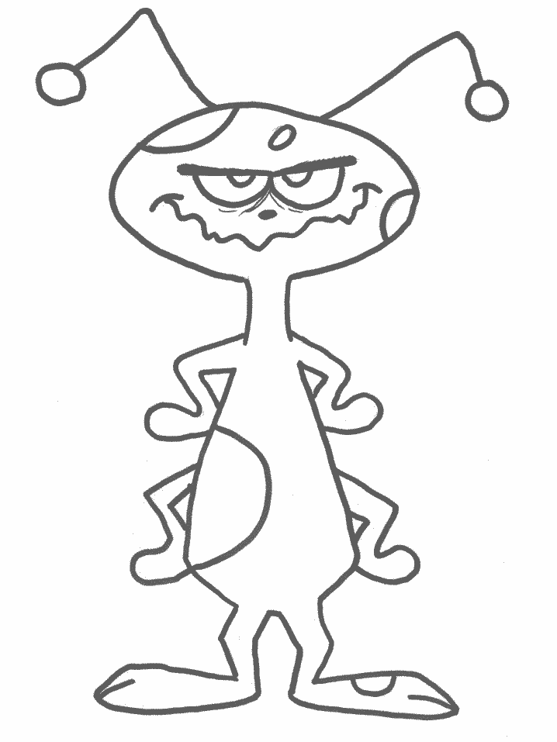

Name__________________

Date__________________

Alien Friends

This Alien is called Talis this is his first time visiting Earth he needs some friends.

Draw Talis some friends and say why they would be good friends to Talis.

___________________________________________________________________________________

____________________________________________________________________________________

_____________________________________________________________________________________________

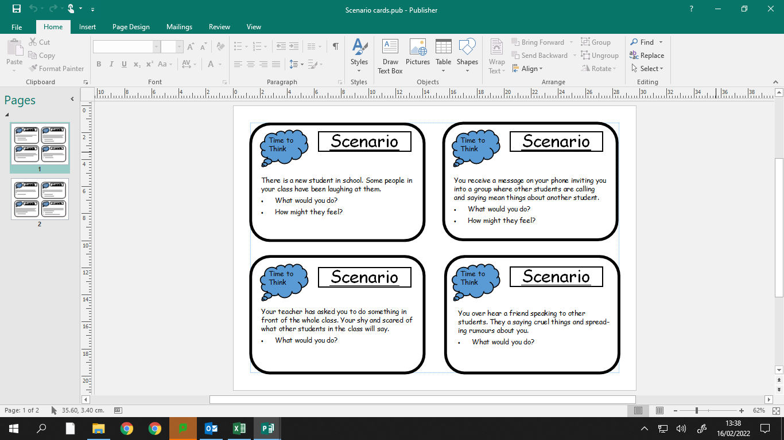

These cards have been designed to help staff start conversations with students with the topic being around being a good friend and bullying.

