 |  |  | Behaviour Plan | Positive Handling | Risk Assessment
 | Example Behaviour Plan |  |  | Plan
 |  |  | x | x | x

About Me Include History of child and progress. How child communicates etc.

What is important to me?

Preventative Strategies

Triggers

- Change of staff

- Change of routine

Support for Triggers

- Explain why the changes have been made.

- Give time to explain feelings

- Worksheets are clear and well presented in order to help access the task.

- clear targets detailing expected behaviour.

- Visual timetable.

- If there is to be a significant change to routine (i.e. a trip out) must be given prior warning.

Behaviours Causing Concern

- become distracted

- disengage from lessons

- Mutters or make rhymes about other students/adults

- occasionally throw objects such as pen-cils/paper/chairs

- Become defiant and refuse to follow in-structions of any kind or communication

Written By:- Supported by:- Date:-

Behaviour Plan

De-Escalation strategies |  | Physical Intervention techniques

- Distraction from trigger/person/activity. E.g. doing a job for staff or focusing on a specific piece of work.

- Clear consistent rules

- Small group work away from students that can be a trig-ger.

- Clear consistent language.

Extra Information on managing a Crisis (Unsuccessful approaches or techniques not used due to health implications)

Strategies to support Repair and Reflection

- When appropriate use a visual repair and reflect to help communicate what has happened and what needs to happen next to make things better.

- When appropriate continue with daily routine. Work can be completed in the calm space to aid transition back into class.

Written By:- Supported by:- Date:-

Risk Assessment Calculator
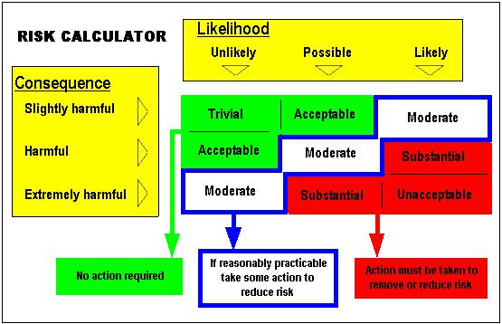

Written By:- Supported by:- Date:-

Kaden Behaviour Plan

Risk assessment

 | Risk Observed |  | Who may be | Risk rating before | Strategies to manage risk | Risk rating after
 |  |  | harmed? | strategies |  | strategies
 |  |  |  | Consequence X Likeli- |  | Consequence X Like-
 |  |  |  | hood = |  | lihood =
 | Interaction with others |  | Staff | substantial | Give clear instructions | Moderate
 | 1. Verbally abusive to staff and |  | Pupils |  | Reminder of targets and rewards.
 | peers

Written By:- Supported by:- Date:-

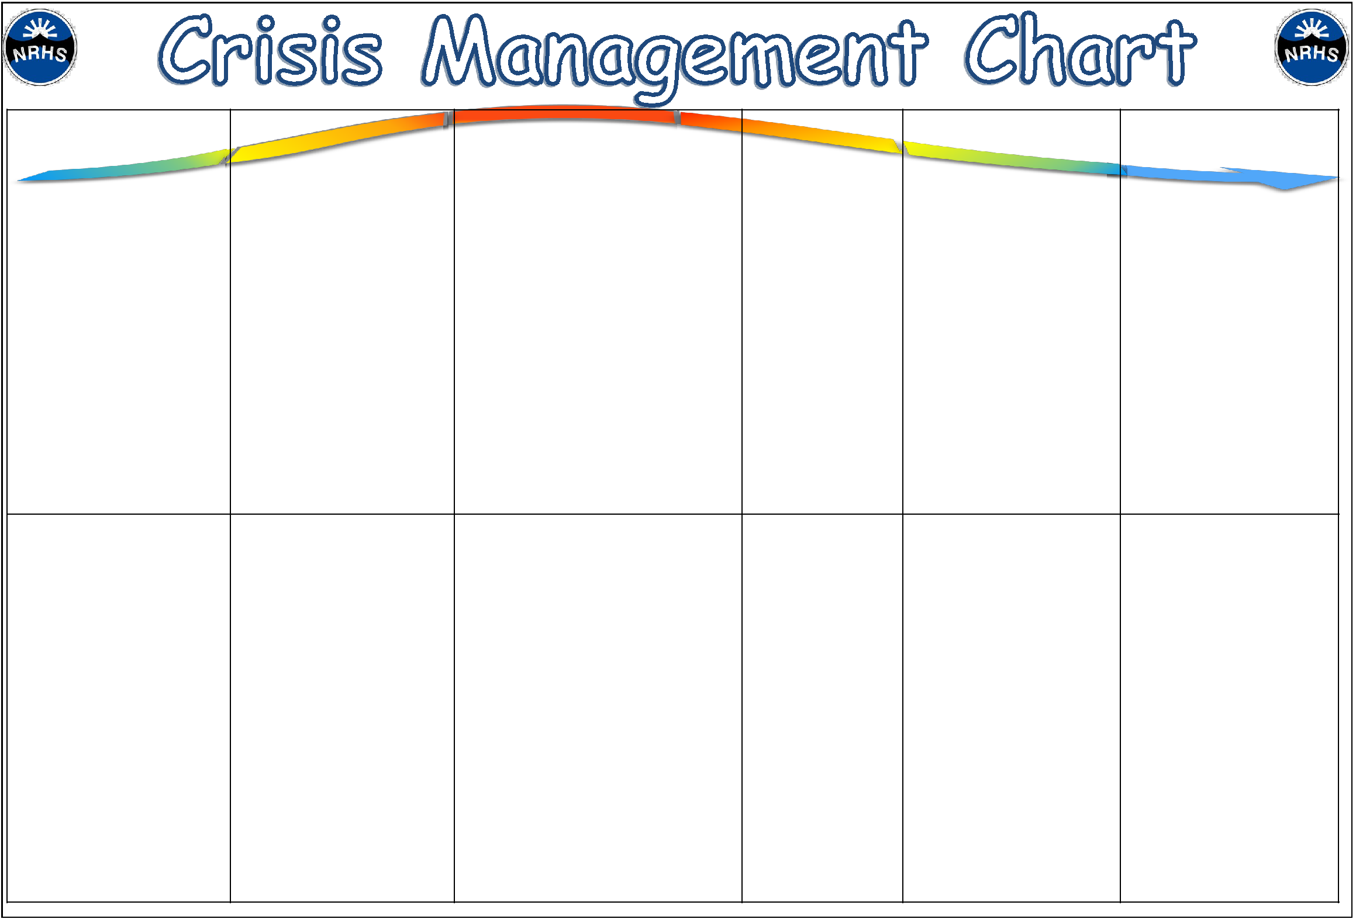

Stage 1– Anxiety/Trigger | Stage 2— Defensive/Escalation | Stage 3—Crisis | Stage 4—Recovery | Stage 5—Depression | Stage 6—Follow Up
What I look like:- | Talking over staff when they | Verbally abusive to staff and peers | Sitting or lying quiet- | Crying. | Able to discuss what hap-
Repetition of inappropriate | are trying to help. | Violent towards staff- hitting and kick- | ly. May sometimes |  | pened and answer ques-
language and swearing. Can | Refusal to follow instructions. | ing. | sleep. |  | tions.
sometimes be aimed at staff | Shouting or swearing |  |  |  | Returning to class safely and
or another student. |  |  |  |  | re-engaging in work.
Using fiddle toy excessively.

What I need:- | Removing from the class- | Directed time out in safe space/area | Quiet space. Some- | Quiet space. Something to | Repair and reflect
Change of task or a more | room or area especially away |  | thing to drink. Twid- | drink. Twiddle toy.
 | from peers. |  | dle toy.
focused task.
Reminder to use a time out
to refocus.
Actions staff might take:- | Change of face |  | Pupil needs space | Pupil needs space and occa- | Return to class and continue
Do a helpful task. |  |  | and occasional re- | sional reminders of support | with routine.
 |  |  | minders of support | available.
Discussing topics that inter- |  |  | available.
est e.g. computers or sports

Written By:- Supported by:- Date:-

Behaviour Plan

Name | Designation | Organisation | Signature | Date

Written By:- Supported by:- Date:-

