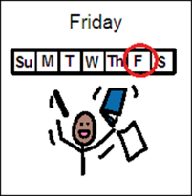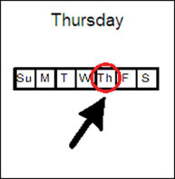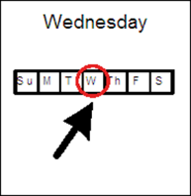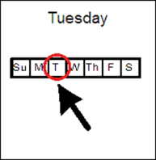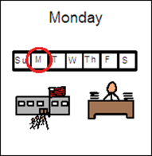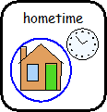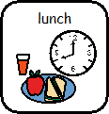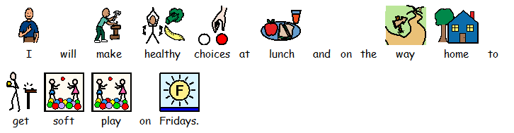

INSERT STUDENT’S PHOTO

**Reward Chart**

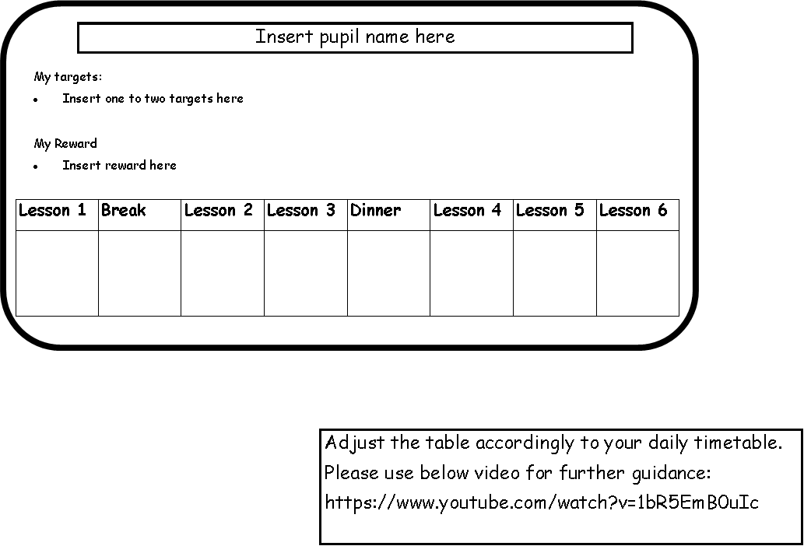

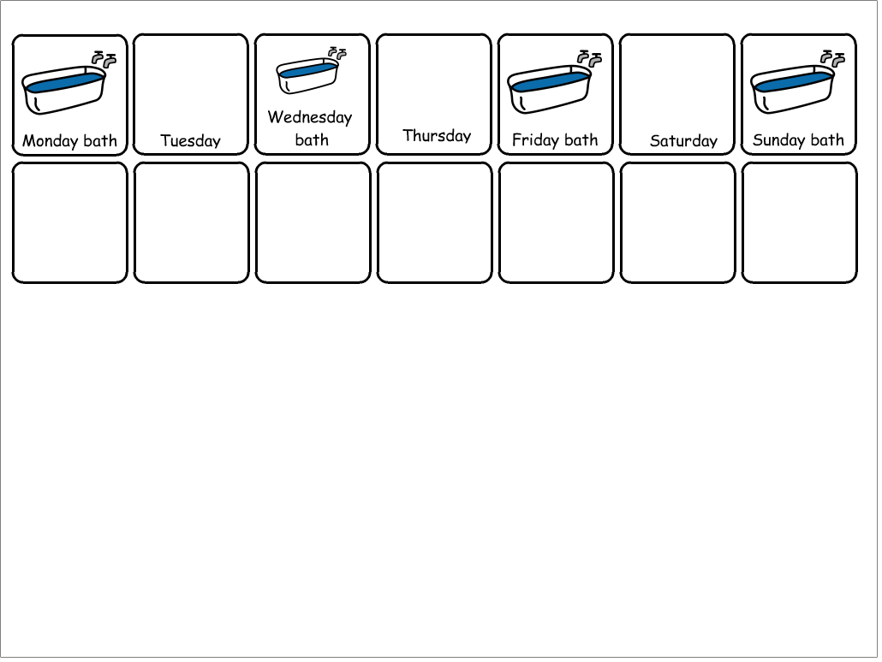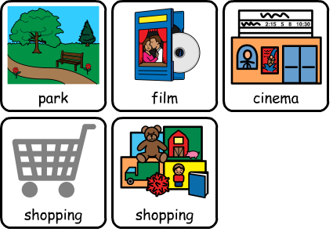

**Reward Chart**

I will have a bath every Monday, Wednesday, Friday and Saturday.

I will earn a tick for each time I have a bath.

4 ticks = a reward

**Behaviour Chart**

**I need to use a quiet voice and work as independently as I can in my lessons to earn a star.**

**If I earn 5 stars, I can have 10 minutes of Lego or colouring at the end of the day.**

Lesson 1 Lesson 2 Lesson 3 Lesson 4 Lesson 5 Lesson 6

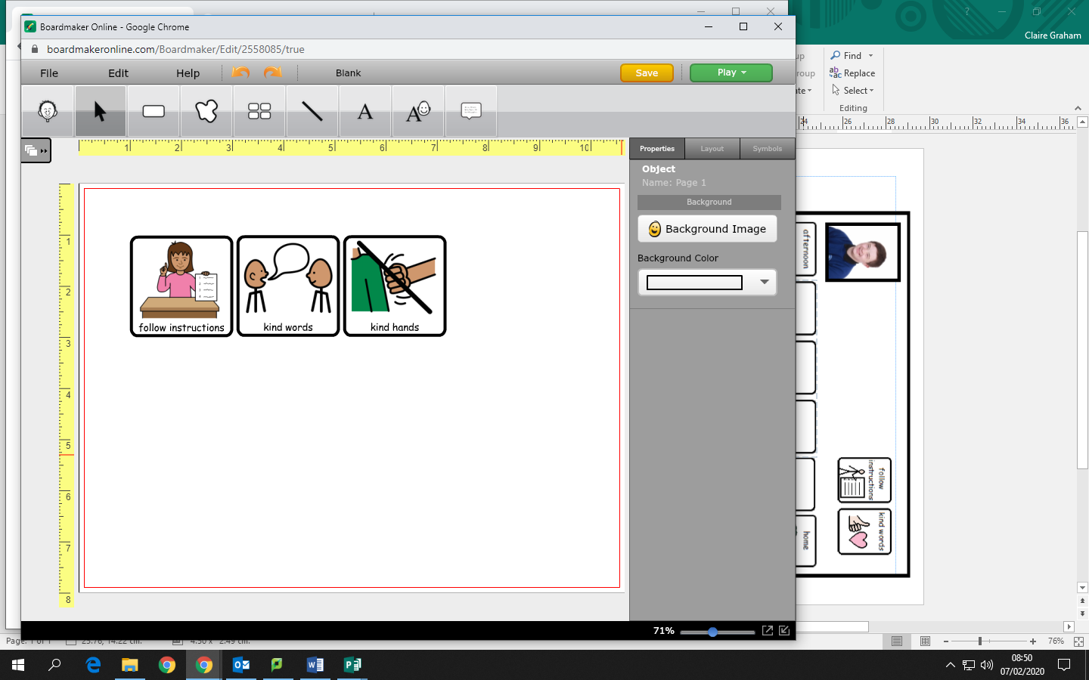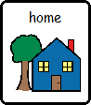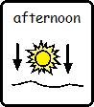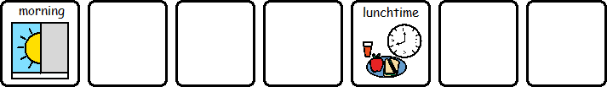

You can add and delete the boxes based on the number of lessons you have in the morning and afternoon.

If you need another symbol for their target other than follow instructions please get in touch or type a different target at the top if this would be better suited to your student.

**INSERT WHAT REWARDS THEY ARE WORKING TOWARDS HERE**

**INSERT**

**STUDENT**

**PHOTO**

**INSERT WHAT REWARDS THEY ARE WORKING TOWARDS HERE**

**INSERT**

**STUDENT**

**PHOTO**