In school I am safe.

My staff are here to keep me safe.

I can talk to my staff about anything and they will listen.

Sometimes I might not like something that someone has done or said and that is ok.

If I don’t like something someone has done or said I can talk to staff about it.

If I feel like I might be getting angry I can use my time out cards to leave the class room and calm outside the classroom.

Insert student phot

**Student Name**

**Social Story**

**When I feel angry.**



I know when I am getting angry and can identify when I need to leave the room.

If I am angry I will use kind hands and feet to keep myself and others safe.

When I am angry my staff will do what they can to keep me and others safe. I can talk and they will listen.

If I am using kind hands and feet my staff will be able to listen to why I am upset.

When I make the choice to leave the room and use kind hands and feet I am keeping myself, students and staff safe

When I am making good choices I am making my friends, family and staff happy.

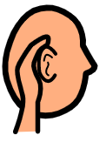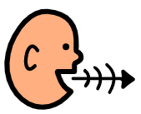

In school I am safe.

 My staff are here to keep me safe.

 I can talk to my staff about anything and they will listen.

 Sometimes I might not like something that someone has done or said and that is ok.

Insert student photo

**Student Name**

**Social Story**

**When I feel angry.**

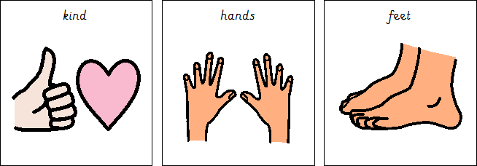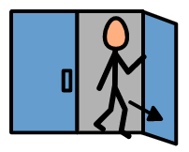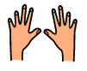

If I don’t like something someone has done or said I can talk to staff about

it.

  If I feel like I might be getting angry I can use my time out cards to leave the class room and calm outside the classroom.

 I know when I am getting angry and can identify when I need to leave the room.

 If I am angry I will use kind hands and feet to keep myself and others safe.

When I am angry my staff will do what they can to keep me and others safe. I can talk and they will listen.

If I am using kind hands and feet my staff will be able to listen to why I am upset.

When I make the choice to leave the room and use kind hands and feet I am keeping myself, students and staff safe



When I am making good choices I am making my friends, family and staff happy.