Behaviour Observation
NORTH RIDGE HIGH SCHOOL

Behaviour Observation Report

Pupil Name:____________________________________
Staff involved:________________________________________________________________

Date & time of observation:-

Context of what was observed

Suggested Strategies
Issue observed | Explanation | Suggestion
EXAMPLE  Too much language used | At various points lots of language was used when giving out an instruction. There was very little processing time given to pupils before next instruction was given out. This resulted in confusion from pupils and unsettled behaviour. | Limit language used when giving out instructions. Give instructions for one task at a time. ‘In your book find page 4’ then wait for that to happen then give next instruction.

Next Steps

Signed:_______________________________________________

Crisis Management
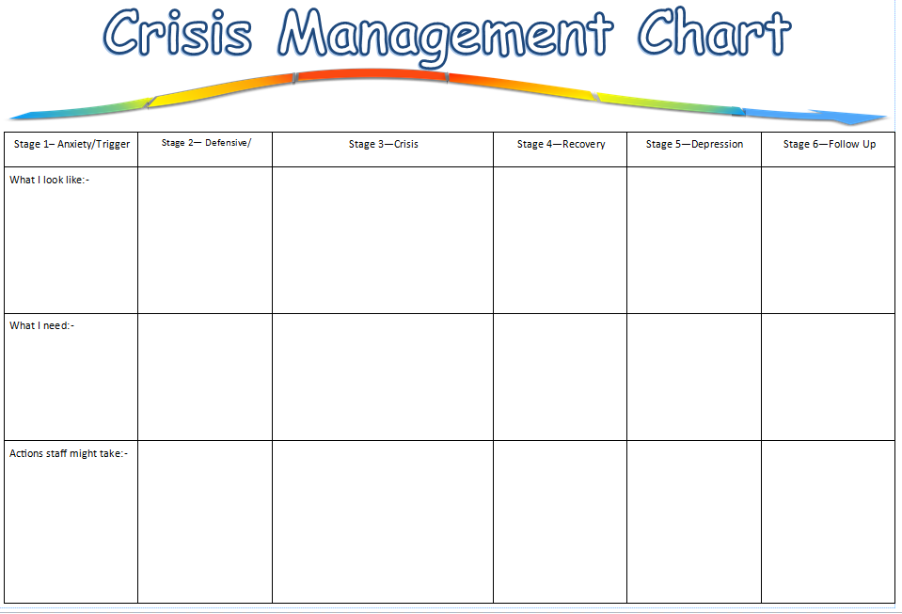

Behaviour Contract

Pupil Name_________________ My School Contract
To help me learn and to feel happy at school I will
- Remain in class and complete my set work to the best of my ability.
- To use “time out” when I am not coping. This means I can go to the quiet, appropriate space that my member of staff will choose. Time out lasts for 10 minutes then I must return to class and continue my work.
- I can attempt to use my communication board to explain how I am feeling.
When I follow this contract I will be get 1 tick per lesson.
If I get 3 ticks in the morning/ afternoon I can have 20 Minutes at the end of the morning/afternoon on an activity of my choice.
Choose 3 activities appropriate activities and agree these with your staff.
1.
2.
3.
If I do not follow my contract
I will not gain my reward that morning/ afternoon.
I will complete work in my break times and lunch times.
My staff will phone home and report to my parents/carers.

Pupil name ___________________________ Date ____________________
Staff name _________________________ Date_____________________
Parent name_________________________ Date_____________________

 | P1 | Break | P2/3 | Reward time | Lunch | P4 | P5/6 | Reward time
Mon
Tue
Wed
Thur
Fri

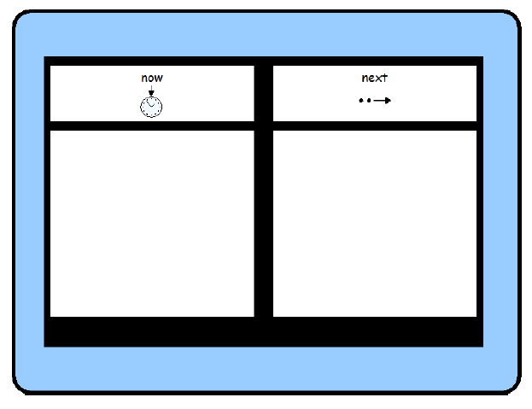

Structure
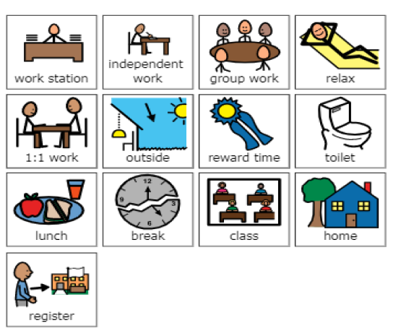

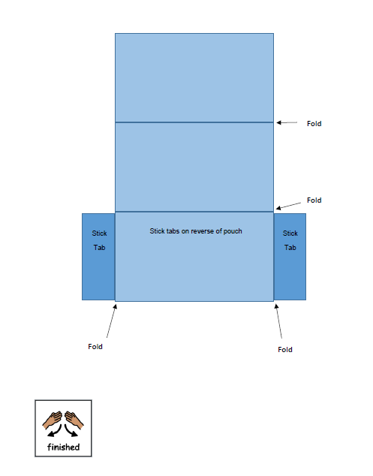

Communication Aids

