

**Personal Hygiene Tool Kit**

This tool kit has been designed to give you some key resources when supporting independent learners with personal hygiene. Inside this tool kit you will find:

• Social story

• Night and day routine tick chart

• Sequencing sheets

All resources have been designed so that you are able to adapt them and personalise them to the needs of your student. All information on how to use these resources including video tutorials and guidance sheets can be found on our website at

https://northridge.manchester.sch.uk/nrhs/resources-and-support/

For any queries please contact:

Email: W.Errock@northridge.manchester.sch.uk

C.Graham@northridge.manchester.sch.uk

**Student Name**

**Social Story**

**Making Healthy Choices.**

Insert student phot

It’s important that I look after myself.

Looking after myself includes washing and brushing my teeth.

Sometimes I have to do things that I don’t want to do to keep myself clean and healthy.

I need to make sure I clean myself every morning and every evening before I go to bed.

When I am keeping myself clean I am making my friends, family and staff happy.

I must shower using shower gel or soap every day.

I must brush my teeth twice a day every day.

I need to make sure I put on clean clothes every day after I have washed.

If I don’t wash or wear clean clothes I will smell.

Sometimes people won’t want to be near me if I smell.



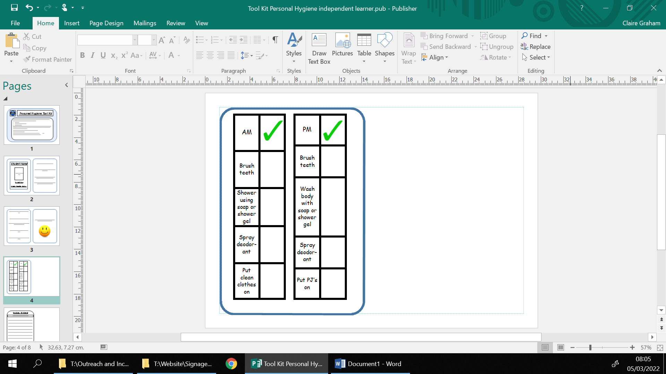

Washing My Hands

I can sequence how to wash my hands

1.__________________________________________

2.__________________________________________

3.__________________________________________

4.__________________________________________

5.__________________________________________

6.__________________________________________

7.__________________________________________

8.__________________________________________

I can sequence how to wash my hair

1.__________________________________________

2.__________________________________________

3.__________________________________________

4.__________________________________________

5.__________________________________________

6.__________________________________________

7.__________________________________________

8.__________________________________________

Washing my hair

Having a shower

I can sequence how to have a shower

1.__________________________________________

2.__________________________________________

3.__________________________________________

4.__________________________________________

5.__________________________________________

6.__________________________________________

7.__________________________________________

8.__________________________________________

Brushing my teeth

I can sequence how to brush my teeth

1.__________________________________________

2.__________________________________________

3.__________________________________________

4.__________________________________________

5.__________________________________________

6.__________________________________________

7.__________________________________________

8.__________________________________________