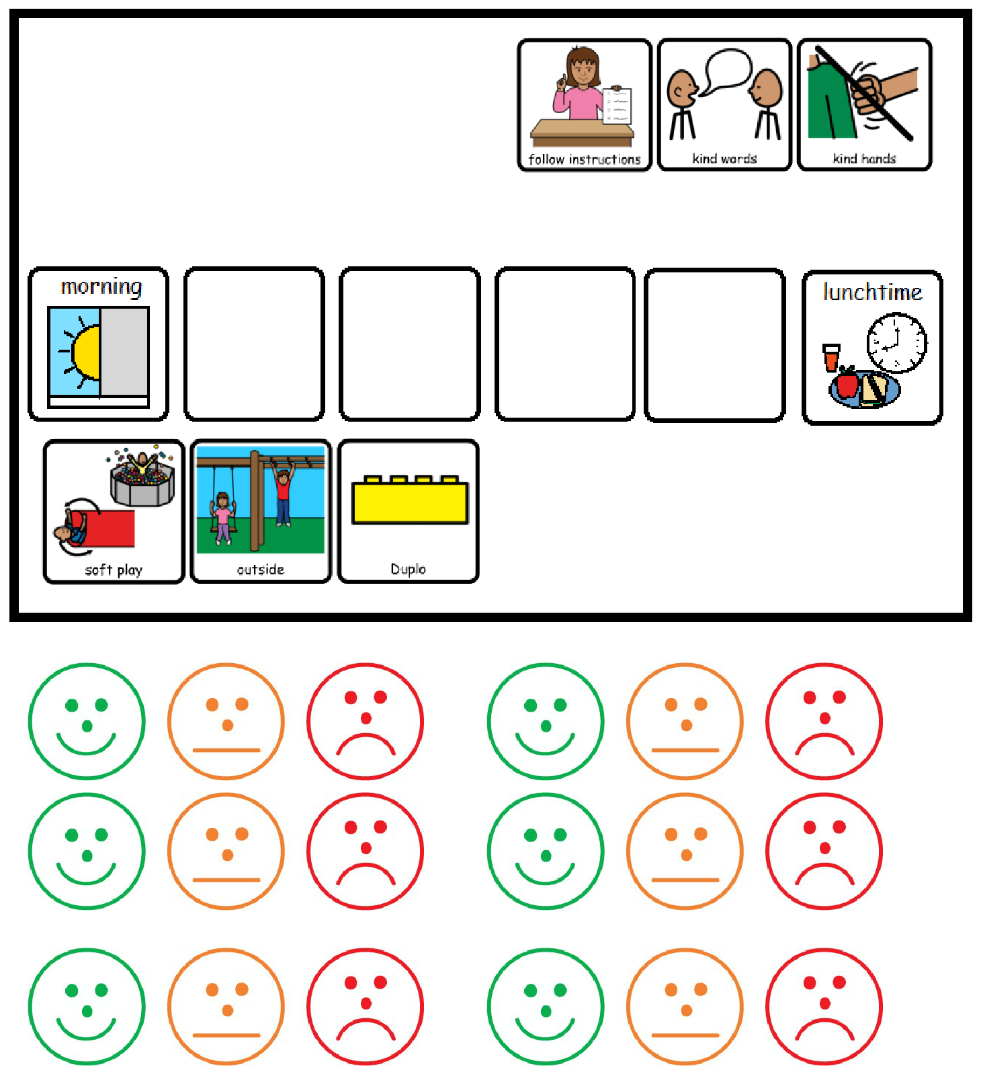

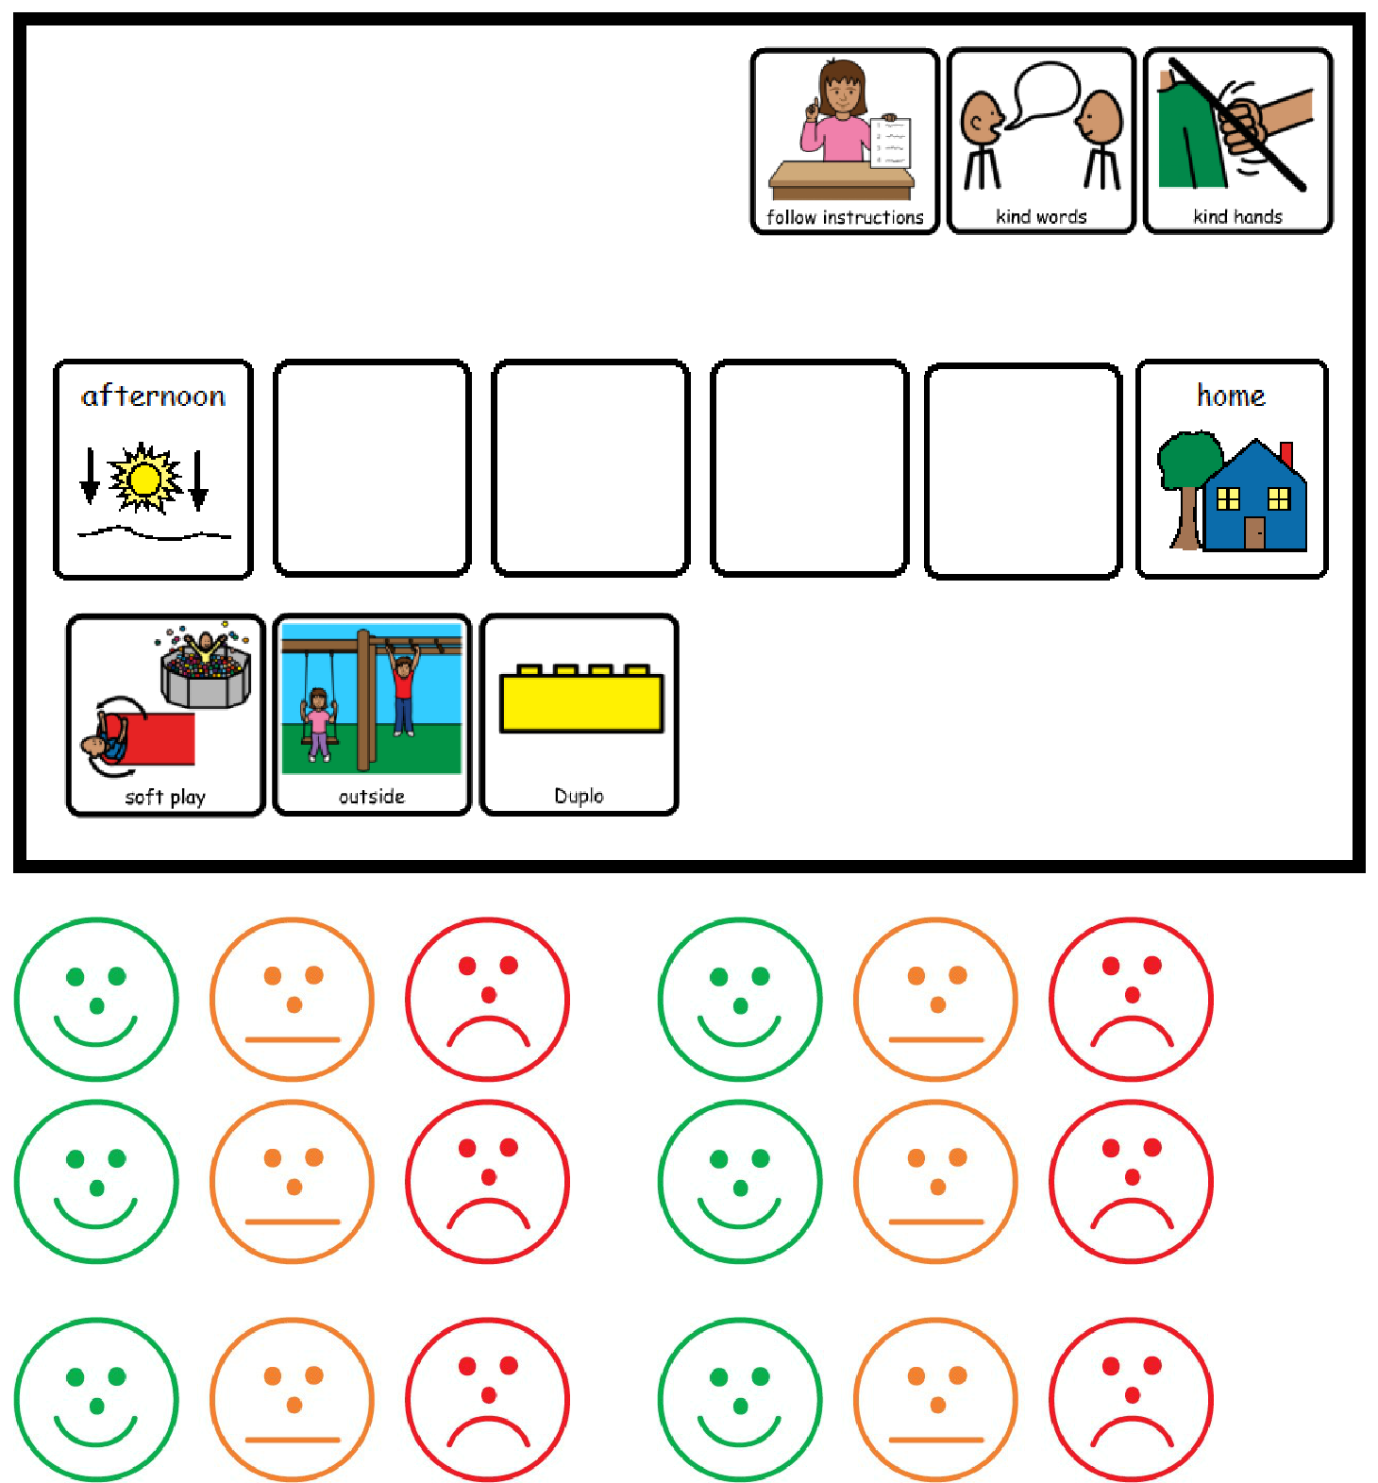

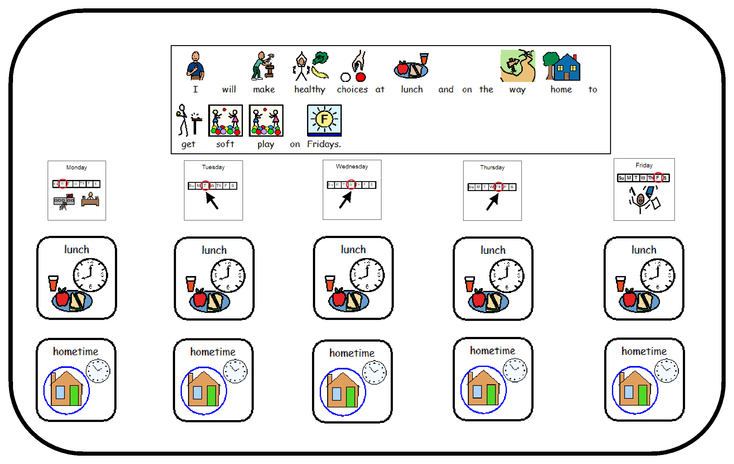**Healthy Choices Reward chart**

**I can earn a tick for each session that I manage my behaviour.**

I must follow staff instructions at all times.

I must behave in an appropriate way and not shout out in class.

|  |  |  |  |  |  |  |  |  |  |  |  |  |  |  |  |  |  |  |  |  |  |  |  |  |  |  |  |  |  |  |  |  |  |  |  |  |
| --- | --- | --- | --- | --- | --- | --- | --- | --- | --- | --- | --- | --- | --- | --- | --- | --- | --- | --- | --- | --- | --- | --- | --- | --- | --- | --- | --- | --- | --- | --- | --- | --- | --- | --- | --- | --- |
|  |  |  |  |  |  |  |  |  |  |  |  |  |  |  |  |  |  |  |  |  |  |  |  |  |  |  |  |  |  |  |  |  |  |  |  |  |
|  |  |  |  |  |  |  |  |  |  |  |  |  |  |  |  |  |  |  |  |  |  |  |  |  |  |  |  |  |  |  |  |  |  |  |  |  |
|  |  |  |  |  | Morning session | | | | | | | | | | |  |  |  | Lunch | | | | |  |  | Afternoon session | | | | | | | | |  |  |
|  |  |  |  |  |  |  |  |  |  |  |  |  |  |  |  |  |  |  |  |  |  |  |  |  |  |  |  |  |  |  |  |  |  |  |  |  |
|  |  |  |  |  |  |  |  |  |  |  |  |  |  |  |  |  |  |  |  |  |  |  |  |  |  |  |  |  |  |  |  |  |  |  |  |  |
|  |  |  |  |  |  |  |  |  |  |  |  | |  | | | |  |  |  |  |  |  |  |  |  |  |  |  |  |  |  |  |  |  |  |  |
|  |  |  |  |  |  |  |  |  |  |  |  |  |  |  |  | |  |  |  |  |  |  |  |  |  |  |  |  |  |  |  |  |  |  |  |  |
|  |  |  |  | Break |  |  |  |  |  |  |  |  |  |  | Dining |  |  | Lunch |  |  |  |  |  |  |  |  |  |  |  |  |
|  |  |  |  |  |  |  |  |  |  |  |  |  |  |  |  |  |  |  | Hall |  |  |  | Club |  |  |  |  |  |  |  |  |  |  |  |  |  |
|  |  |  |  |  |  |  |  |  |  |  |  |  |  |  |  |  |  |  |  |  |  |  |  |  |  |  |  |  |  |  |  |  |  |  |  |
|  |  |  |  |  |  |  |  |  |  |  |  |  |  |  |  |  |  |  |  |  |  |  |  |  |  |  |  |  |  |  |  |  |  |  |  |  |
|  |  |  |  |  |  |  |  |  |  |  |  |  |  |  |  |  |  |  |  |  |  |  |  |  |  |  |  |  |  |  |  |  |  |  |  |  |

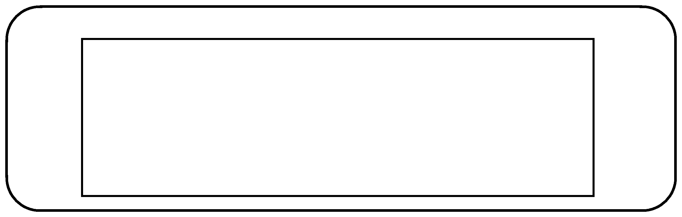

If I am having a problem…

**I need to find an adult I know.**

**Talk about the problem.**

**Find a solution**

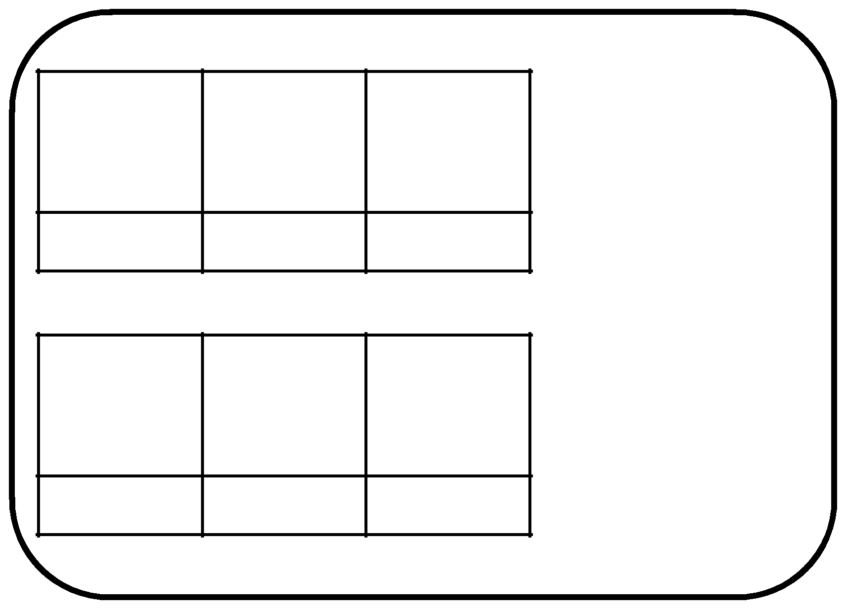Morning

3 ✓=

Afternoon

3 ✓=

