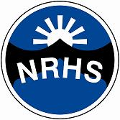
Staff Training Request
NORTH RIDGE HIGH SCHOOL
OUTREACH SUPPORT TEAM

School Name:
Please select the area/s you are requesting further support through staff training:

Behaviour Support
Learning and Communication Support
Structure Support
Physical Support
Social and Emotional Support
Specific learning difficulty/ disability

Please outline specific key elements you would like to focus on to support the development of your staff. Cover as much information as possible to support your request.

