

**Bereavement Tool Kit**

This tool kit has been designed to give you some key resources when supporting independent learners with bereavement. Inside this tool kit you will find:

• Time out cards

• A social story

• My special person worksheet

All resources have been designed so that you are able to adapt them and personalise them to the needs of your student. All information on how to use these resources including video tutorials and guidance sheets can be found on our website at

https://northridge.manchester.sch.uk/nrhs/resources-and-support/

For any queries please contact:

Email: W.Errock@northridge.manchester.sch.uk

C.Graham@northridge.manchester.sch.uk

Students are able to present these to a staff member in class to take some time out of lesson to talk to someone or compose themselves before returning to lesson.

Time Out



Time Out



Time Out



**Student Name**

**Social Story**

**When someone I know has died.**

Insert student phot

It’s part of life to get to know people and love the people you like, like family and friends.

When someone dies it means they are no longer alive and everything that made them a person has stopped working.

When this happens it’s ok to feel lots of different emotions.

People who also knew them might feel lots of different emotions too.



When someone I care about has died I might feel like crying this is ok, tears let out sad feelings.

I know I can speak to my family and teachers about how I am feeling.

I can talk to my family and friends about different memories that make me smile about the person who has died.

Other people might also be feeling sad and may be crying this is ok. They may need some time to themselves and then you can share your memories with them too.

This person was very special to me but I know I have lots of people around me I can talk to so I can feel happy again.

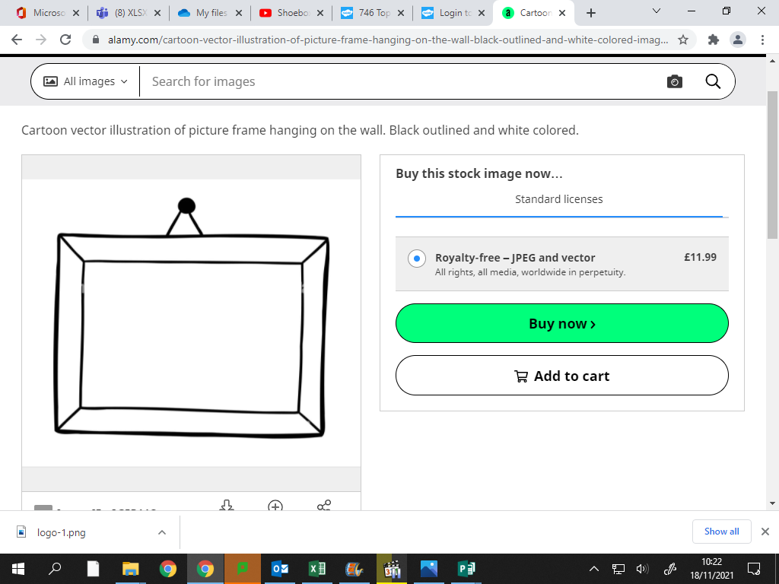

My Special Person

Draw one of your favourite memories with this person

____________________________________________

___________________________________________

____________________________________________

____________________________________________

___________________________________________

____________________________________________

____________________________________________

The things I liked about this person

_____________________

_____________________

_____________________

_____________________

_____________________

_____________________