

**Healthier Choices Tool Kit**

This tool kit has been designed to give you some key resources when supporting independent learners to make healthier choices. Inside this tool kit you will find:

• Weekly staying active tick chart

• Food Diary

• Lunch box tick list

• Social story

All resources have been designed so that you are able to adapt them and personalise them to the needs of your student. All information on how to use these resources including video tutorials and guidance sheets can be found on our website at

https://northridge.manchester.sch.uk/nrhs/resources-and-support/

For any queries please contact:

Email: W.Errock@northridge.manchester.sch.uk

C.Graham@northridge.manchester.sch.uk

Staying active checklist

Tick when you have completed a 30 minute active activity this can include, going for a walk, just dance, playing football in the garden or park or any other active that involves standing and moving around. Try to tick 4 of the boxes each week

Monday

Tuesday

Wednesday

Thursday

Friday

Saturday

Sunday

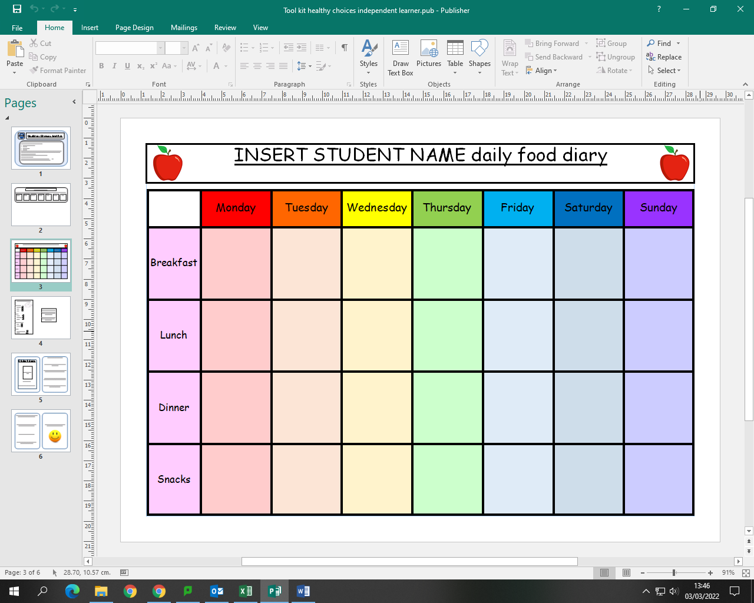

INSERT STUDENT NAME daily food diary

My Lunch Box check list

The Main:

• Sandwich

• Pasta

• Salad

Drink:

• Water

• Fruit Juice

• Cordial

Healthy Snack:

• Fruit

• Yoghurt

Treat:

• X1 packet of crisps

• biscuit

The idea is that the student takes responsibility for packing their own lunch and they can pack one item from each section.

This is to help stop students bringing excessive amounts of sweets and crisps into school.

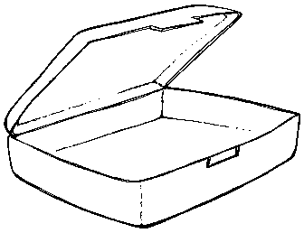

Staying healthy is very important.

We only have one body in life and it’s up to us to take care of it.

Junk food and deserts may taste very nice but too much of them can be harmful to our bodies.

If we eat too much junk food and deserts it can make us gain weight and put strain on our hearts.

Eating too much junk food and deserts can make you feel sick sometimes.

Insert student phot

**Student Name**

**Social Story**

**Making Healthy Choices.**



If I am full I can tell a teacher or my family and they will take the food away this is ok.

I will make healthy choices in school and at home to help take care of my body.

It’s ok to have a treat once a week.

I know I can talk to my staff about healthy choices and how I am feeling.

When I am making good choices I am making my friends, family and staff happy.