

**Healthier Choices Tool Kit**

This tool kit has been designed to give you some key resources when working with supported learners to make healthier choices. Inside this tool kit you will find:

• Weekly staying active tick chart

• Reward chart

• Social story

All resources have been designed so that you are able to adapt them and personalise them to the needs of your student. All information on how to use these resources including video tutorials and guidance sheets can be found on our website at

https://northridge.manchester.sch.uk/nrhs/resources-and-support/

For any queries please contact:

Email: W.Errock@northridge.manchester.sch.uk

C.Graham@northridge.manchester.sch.uk

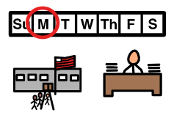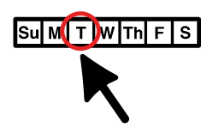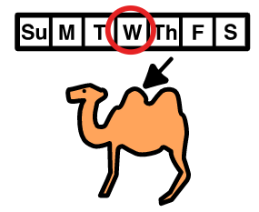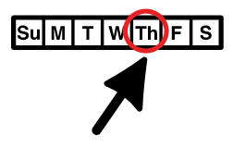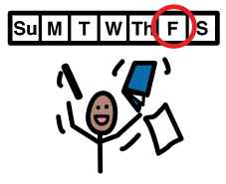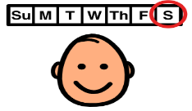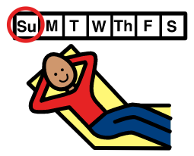

Staying active checklist

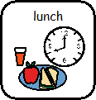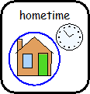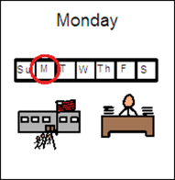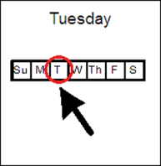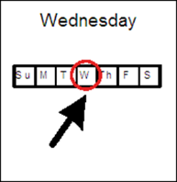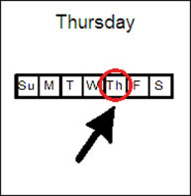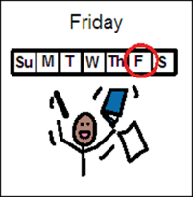

**INSERT STUDENT NAME reward chart**

**Please insert targets and rewards in this area.**

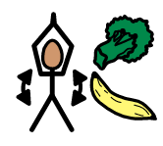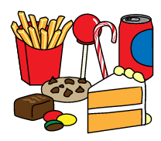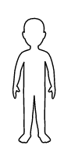

**Student Name**

**Social Story**

**Making Healthy Choices.**

Insert student phot

Staying healthy is very important.

 We only have one body in life and it’s up to us to take care of it.

 Junk food and deserts may taste very nice but too much of them can be harmful to our bodies.

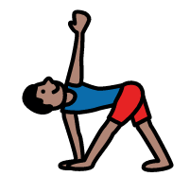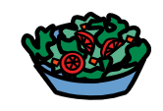

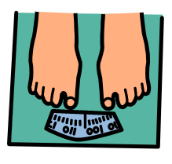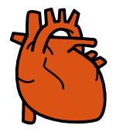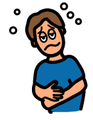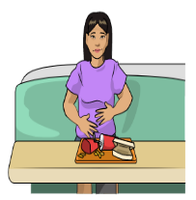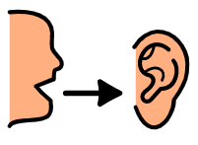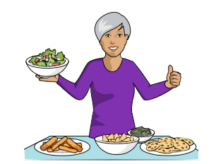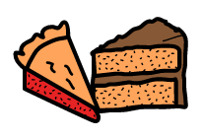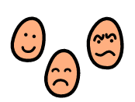

If we eat too much junk food and deserts it can make us gain weight and put strain on our hearts.

 Eating too much junk food and deserts can make you feel sick sometimes.

 If I am full I can tell a teacher or my family and they will take the food away this is ok.

I will make healthy choices in school and at home to help take care of my body.

 It’s ok to have a treat once a week.

 I know I can talk to my staff about healthy choices and how I am feeling.



When I am making good choices I am making my friends, family and staff happy.