

This tool kit has been designed to give you some key resources when working with supported learners who are transitioning to a new school. Inside this tool kit you will find:

• Social story

• Worksheet about the new school/class

• Yearly achievements sheet

All resources have been designed so that you are able to adapt them and personalise them to the needs of your student. All information on how to use these resources including video tutorials and guidance sheets can be found on our website at

https://northridge.manchester.sch.uk/nrhs/resources-and-support/

For any queries please contact:

Email: W.Errock@northridge.manchester.sch.uk

C.Graham@northridge.manchester.sch.uk

**Transition Tool Kit**

**Student Name**

**Social Story**

**My new class.**

Insert student phot

On INSERT DATE

The new school year will begin.

This is the door I am going to use.



INSERT A PICTURE OF SCHOOL ENTRANCE

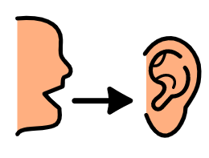

I will be in Yr _____ when I return to school.

Moving to a new class means I am growing up this is good

My new class will be ____________

 The staff that will be working with me will be

Moving to a new class is a good opportunity to make new friends

If I am worried about anything I can speak to staff and they will support me.

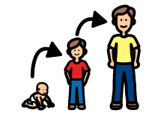

INSERT PICTURES OF STAFF



When I am speaking to my staff and telling them how I feel I am making my friends, family and staff happy.

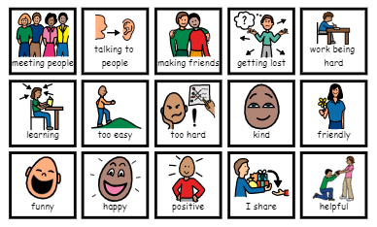

**My New School**

Things I’m excited about:

Things I’m worried about:

What I can do to help with the things I’m worried about:

Use the symbols to cut and stick

This can be used as a sheet to complete 1:1 or for the student to complete during a break time but should be discussed with the pupil once completed

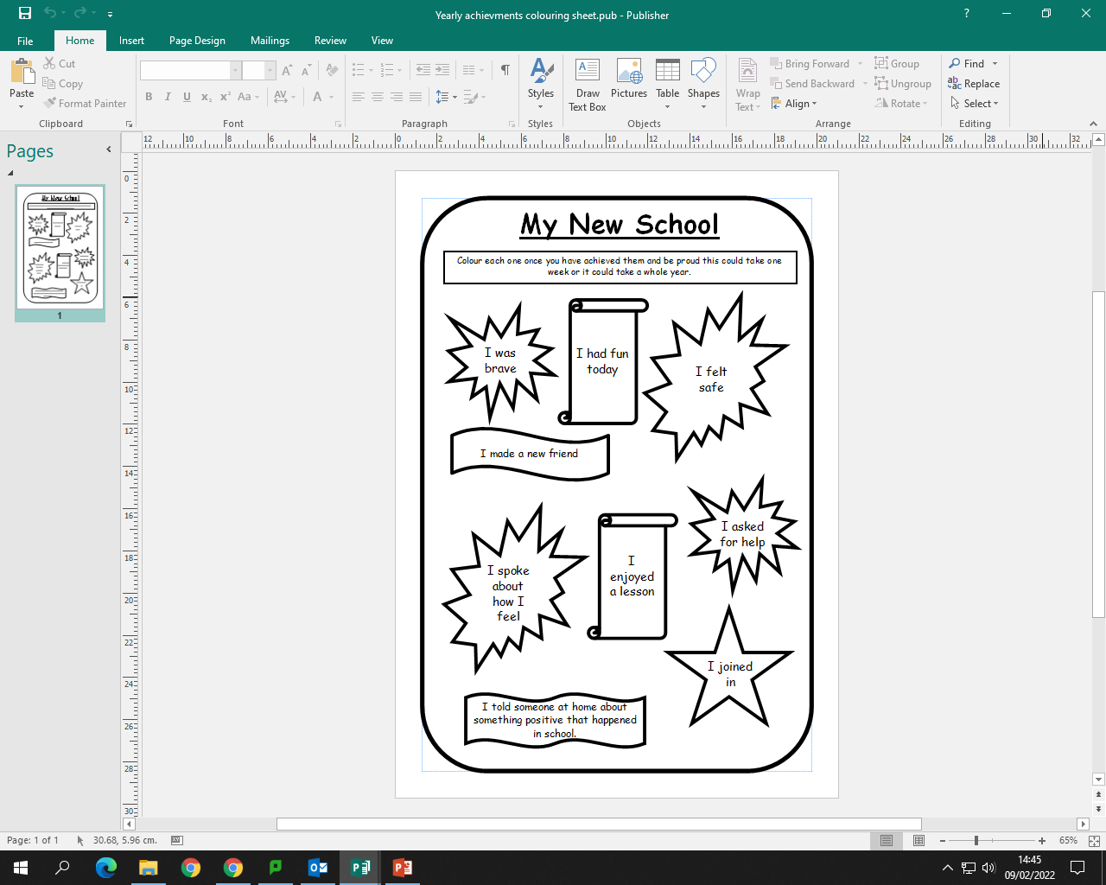

This can be used as a sheet to complete 1:1 or at home. The student can either keep it private or choose to share it with parents/teachers.