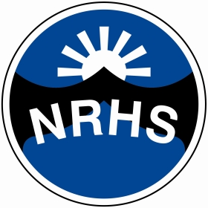
North Ridge High School – July 2021
KS3 Long Term Plan – Science
Year | Autumn 1 | Autumn 2 | Spring 1 | Spring 2 | Summer 1 | Summer 2
 | Biology |  | Chemistry |  | Physics
1 | My Body : organs and senses | Learning about Cells | Properties of materials | Uses of everyday materials | Energy | What is Electricity?
2 | Why are plants important? | Healthy Lifestyles:  Food and Digestion  Heart, Lungs and Circulation | Solids, Gases and liquids | Changing materials | Space: Planets & stars | Forces and magnets
3 | Living things and their environment | Life Cycles: Growing & reproduction | Earth and its Atmosphere | Rocks and their properties | Waves: What is sound? | Waves:All about light

